Hartlepool Athletics Club
‘Stay Fit Campaign’
Weekend Challenge
Week 5

30x Incline Sprints
This weekends challenge is to complete 30x Incline Sprints
These can be completed in sections over the weekend
You can find inclines in the street and at local fields
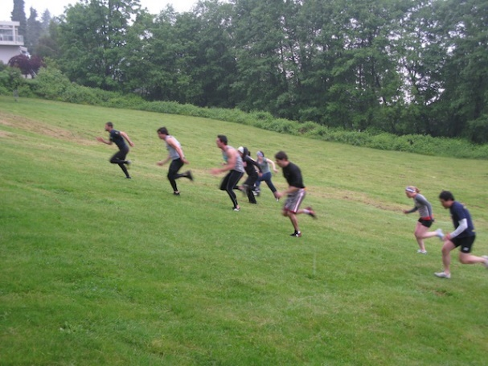
Sprints should last between 6 to 10s

Have Fun!!

