Hartlepool Athletics Club
‘Stay Fit Campaign’

Weekend Challenge
Week 12

Sally Up, Sally Down Challenge has returned for 1 final time!
Use this YouTube video to play the song and off you go!
https://youtu.be/koMp3ei4xJw
3 tickets up for grabs!
Fridays – Hip Thrusts

Saturday – Bulgarian Split Squats

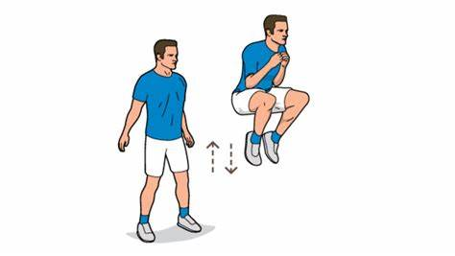
Sunday – Tuck Jumps

Enjoy!

Send your efforts into John via WhatsApp or Email hartlepoolathletics@gmail.com

